The DevOps team is tasked with setting up a highly available web application using AWS. To achieve this, they plan to use an Auto Scaling Group (ASG) to ensure that the required number of EC2 instances are always running, and an Application Load Balancer (ALB) to distribute traffic across these instances. The goal of this task is to set up an ASG that automatically scales EC2 instances based on CPU utilization, and an ALB that directs incoming traffic to the instances. The EC2 instances should have Nginx installed and running to serve web traffic.
- Create an EC2 launch template named devops-launch-template that specifies the configuration for the EC2 instances, including the Amazon Linux 2 AMI, t2.micro instance type, and a security group that allows HTTP traffic on port 80.
- Add a User Data script to the launch template to install Nginx on the EC2 instances when they are launched. The script should install Nginx, start the Nginx service, and enable it to start on boot.
- Create an Auto Scaling Group named devops-asg that uses the launch template and ensures a minimum of 1 instance, desired capacity is 1 instance and a maximum of 2 instances are running based on CPU utilization. Set the target CPU utilization to 50%.
- Create a target group named devops-tg, an Application Load Balancer named devops-alb and configure it to listen on port 80. Ensure the ALB is associated with the Auto Scaling Group and distributes traffic across the instances.
- Configure health checks on the ALB to ensure it routes traffic only to healthy instances.
- Verify that the ALB's DNS name is accessible and that it displays the default Nginx page served by the EC2 instances.

Use below given AWS Credentials: (You can run the showcreds command on aws-client host to retrieve these credentials)
Console URL | https://457440888221.signin.aws.amazon.com/console?region=us-east-1
Username | kk_labs_user_154758
Password | GL!51uiLM5f^
Start Time | Wed Jan 14 05:21:19 UTC 2026
End Time | Wed Jan 14 06:21:19 UTC 2026
Notes:
- Create the resources only in us-east-1 region.
- To display or hide the terminal of the AWS client machine, you can use the expand toggle button as shown below:
Solutions:-

Step 1: Create the Launch Template
- Sign in to the AWS Console using the provided credentials.
- Navigate to EC2 → Launch Templates → Create launch template.
- Enter:
  - Name: devops-launch-template
  - AMI: Amazon Linux 2 (latest AMI ID in us-east-1)
  - Instance type: t2.micro
  - Key pair: (optional, if you want SSH access)
- Network settings:
  - Create or select a Security Group that allows inbound traffic on port 80 (HTTP).
- Advanced details → User Data: paste the script below:
#!/bin/bash
dnf update -y
dnf install -y nginx
systemctl start nginx
systemctl enable nginx
This ensures Nginx is installed, started, and enabled on boot.

Step 2: Create the Auto Scaling Group (ASG)
- Go to EC2 → Auto Scaling Groups → Create Auto Scaling group.
- Name: devops-asg.
- Select the Launch Template: devops-launch-template.
- Choose your VPC and subnets (pick at least 2 subnets across different AZs for high availability).
- Configure group size:
  - Minimum capacity: 1
  - Desired capacity: 1
  - Maximum capacity: 2
- Scaling policy:
  - Select Target tracking scaling policy.
  - Metric type: Average CPU utilization.
  - Target value: 50%.
🌐 Step 3: Create Target Group and Application Load Balancer
- Go to EC2 → Target Groups → Create target group.
  - Name: devops-tg
  - Target type: Instances
  - Protocol: HTTP
  - Port: 80
  - VPC: same as ASG.
  - Health check path: / (default Nginx page).
- Go to EC2 → Load Balancers → Create Load Balancer → Application Load Balancer.
  - Name: devops-alb
  - Scheme: Internet-facing
  - IP type: IPv4
  - Select at least 2 subnets across AZs.
  - Security group: allow inbound HTTP (port 80).
  - Listener: HTTP on port 80.
  - Default action: forward to devops-tg.
- Register the ASG with the target group:
  - In the ASG settings, attach the target group devops-tg.

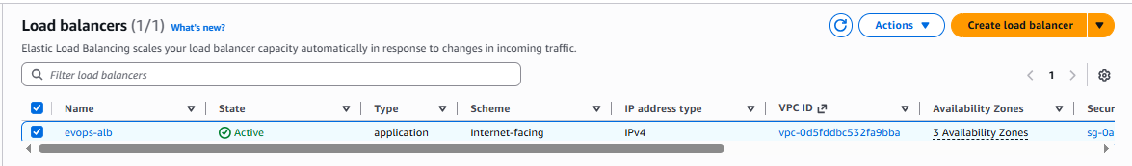
Step 4: Verify Setup
- Wait for the ASG to launch the first EC2 instance.
- Check Target Group → Targets: ensure the instance shows as healthy.
- Copy the DNS name of the ALB (found under devops-alb description).
- Open it in a browser — you should see the default Nginx welcome page.

Copy the DNS name of the ALB (found under devops-alb description).
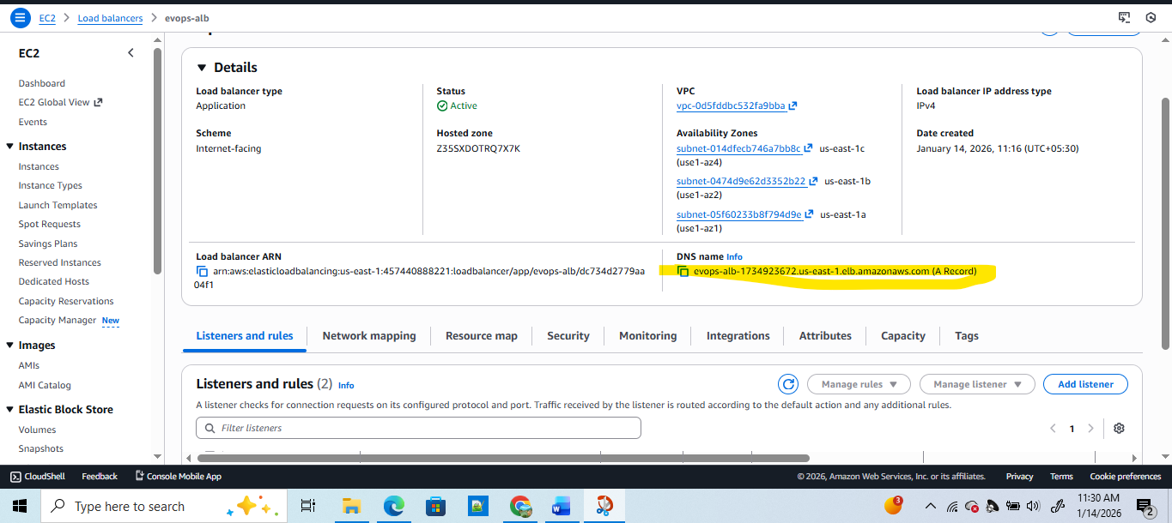

DNS name Info
evops-alb-1734923672.us-east-1.elb.amazonaws.com (A Record)

